|  |  |  |  |
| --- | --- | --- | --- |
|  | **Ethnic group, England, and Wales: Census 2021** | |  |
| **Constituency data: Ethnic groups**  **The ethnic groups of usual residents and household ethnic composition in England and Wales, Census 2021 data.**  **Find out how many people identify with different ethnic groups in your constituency, based on census data** | |
|  | **Report from: Bhawna Sharma 03/08/2024**  **Data source: Ethnicity provided by T.Das**  **Also available at house of commons library**  **2021 census results: Ethnic groups in your constituency (parliament.uk)** | |  |
|  |  |  |
|  | |  |

# Contents

Contents 2

Why do a Census? 3

Who handles the census? 4

How are ethnic groups defined in the census? 4

Explore constituency data 4

Regions of England and Wales 7

Most ethnically diverse Regions 8

Diversity of Ethnic groups across constituencies 8

Non-White Population per Constituency 9

Socio-economic groups by ethnicity 10

Percentage of people within each ethnic group in the different socio-economic groups 11

Percentage of households having multiple ethnic groups varies by Area Name 12

Geospatial Analysis 13

How can this data inform policymaking and resource allocation? 14

Using Dashboards for Actionable Insights 15

Language Support and Education 15

Healthcare Access 15

Employment Opportunities 16

Community Integration 16

Youth Engagement and Recreation 16

Anti-Discrimination Policies and Awareness 16

# Why do a Census?

The census is unique in the level of detail and consistency it provides, as it aims to cover every person usually resident in the UK.

Uses for census data include:

• funding formulae used to distribute central government resources to other organizations such as the devolved administrations (via the Barnett formula), local authorities and health bodies.

• policy development and planning by central, local, and regional government, in areas including equalities, housing, transport, employment and health.

• census data continues to underline much social research, both within and outside government, and businesses use it to target their marketing and location policies. Government researchers use census data to assess the representativeness of other social surveys.

## Who handles the census?

The United Kingdom Statistics Authority (UKSA), the arm’s-length public body responsible for official statistics in the UK, holds the statutory powers to conduct a census in England and Wales.

## How are ethnic groups defined in the census?

The most recent census asked people about their ethnic group. The census was carried out in March 2021 in England, Wales.

The census questionnaire included tick-boxes which were grouped under broad headings (e.g., ‘Asian or Asian British’), with more specific ethnic groups to select underneath (such as ‘Indian’ or ‘Pakistani’).

Across England and Wales, 82% of people identified with a White ethnic group, 9% with an Asian ethnic group, 4% with a Black ethnic group, 3% with Mixed or Multiple ethnic groups, and 2% with other ethnic groups.

Ethnicity is multi-dimensional and subjective, with several ways in which a person may choose to define their ethnic group. This may include common ancestry, elements of culture, identity, religion, language, and physical appearance. It is accepted that ethnic groups do include all these aspects, and others, in combination.

In this data set 19 ethnic groups has been used to see the ethnic diversity across England and Wales.

# Explore constituency data

In Power BI dashboard report: -

Use the dropdown menu below to select the constituency you are interested in and view statistics on the population by ethnic group.

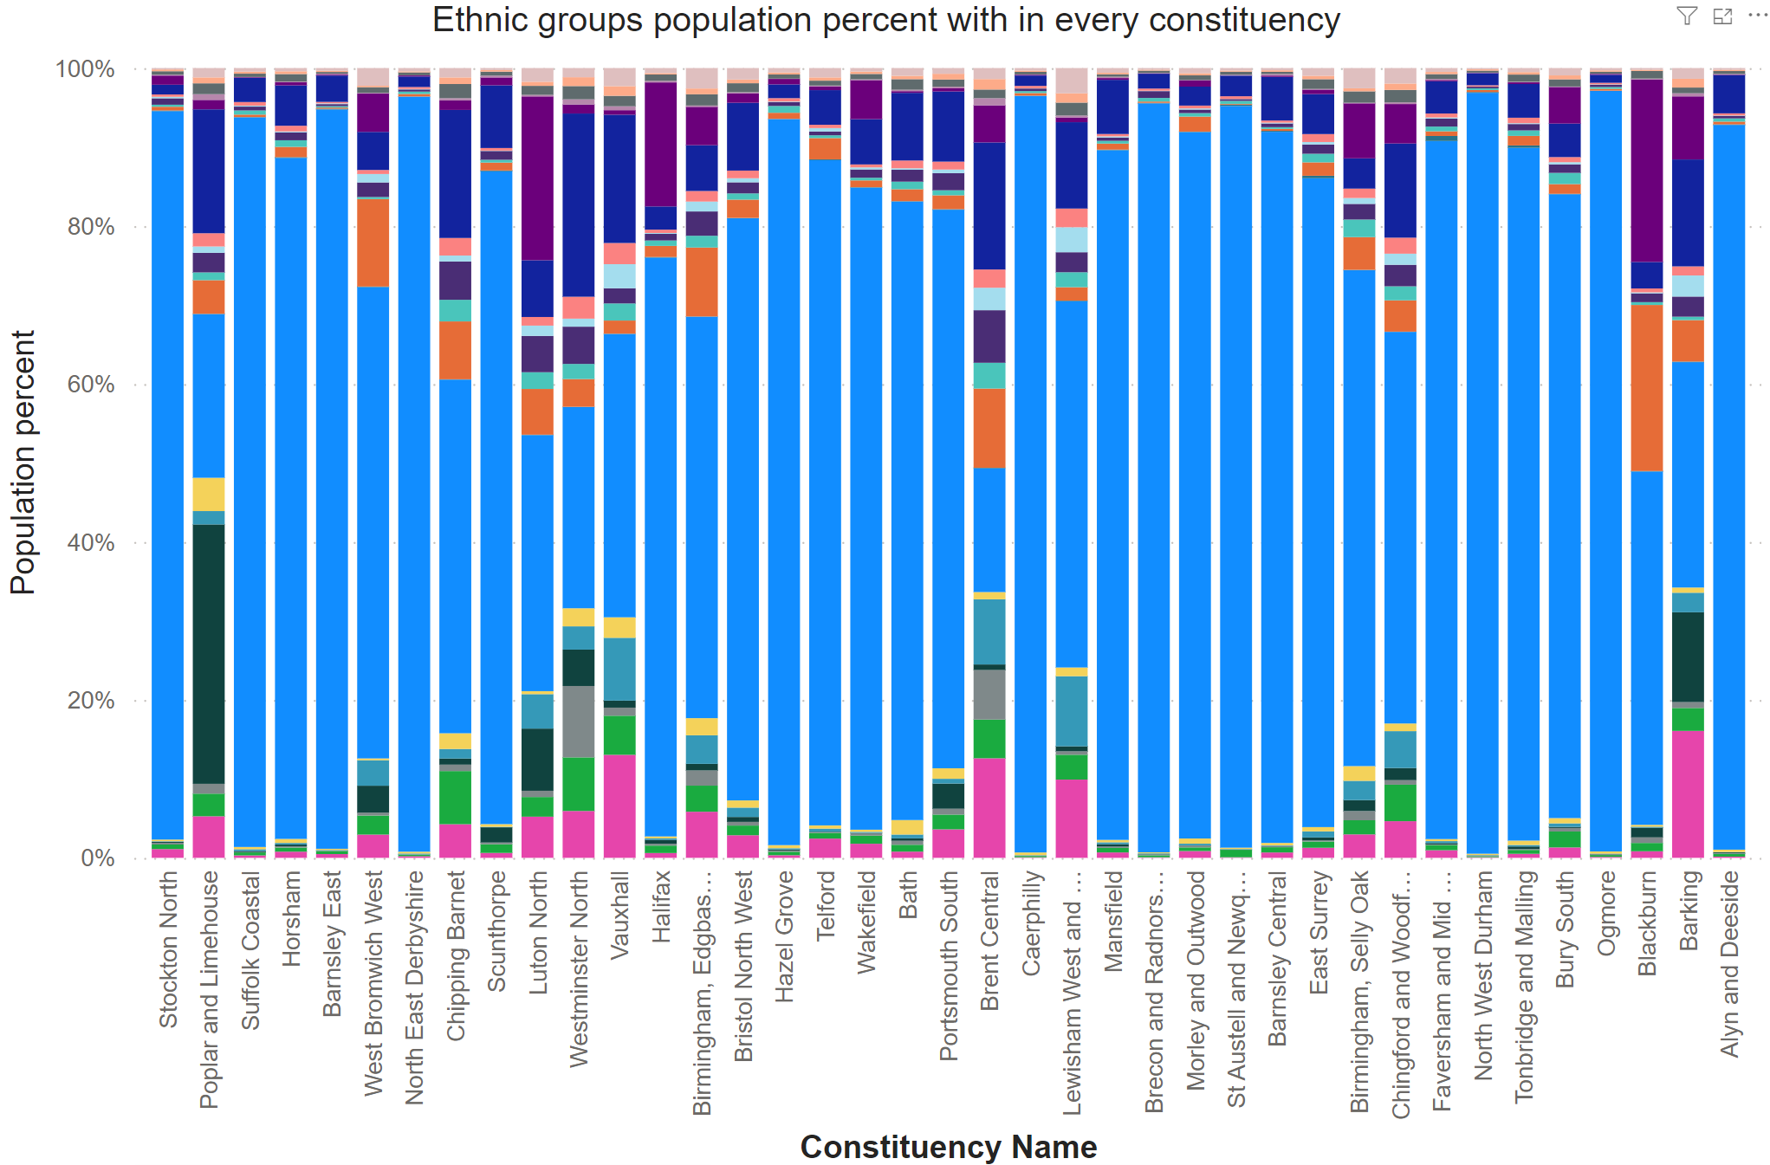

To analyze the distribution of specific Ethnic groups within constituencies.

We can Use Filter to select Ethnic group and can see the top 10-most populated constituencies with that ethnic group both in numbers and percentage.

Detailed bar charts to present demographic characteristics.

The below bar charts show the data for African ethnic group and through that we can see Erith and Thamesmead is first in rank and followed by Camberwell and Peckham and so on.

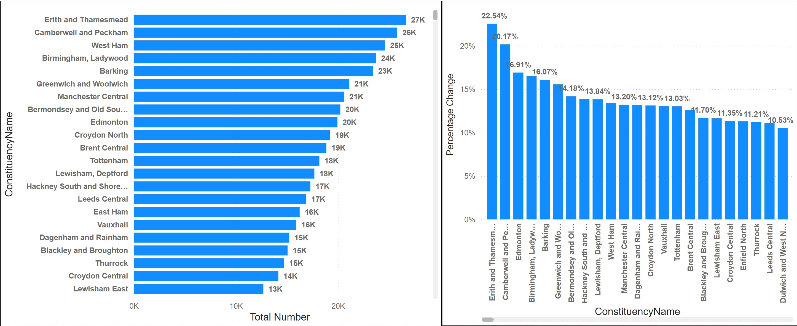

Statistics on Ethnic group population has also been shown across different Regions of England and Wales.

Average National, Average Regional and Average constituency population has also been shown in the report through line graphs and deviation of average Constituency population from average National population can be seen in dashboard 4.

As per the Power Bi data report for ethnicity the Top 10 most populated ones are West ham, poplar and Limehouse, East ham, Manchester central and Slough. Most of them are in the London Region.

Leicester East has the highest Indian population and St. Ives has the least. For African its Erith and Thamesmead and least in Southeast Cornwall. For "White: English, Welsh, Scottish, Northern Irish or British" its Isle of Wight and least in Brent North. For Bangladeshi, Its Poplar and Limehouse and least in

Selby and Ainsty. Similarly, you can easily find it for other ethnic groups through number 3 dashboard report.

Other main points discovered while creating the Power Bi reports are as follows:

Census changes for the years 2011 and 2021 can be seen through dashboard 5 report.

* In 2021, 81.7% (48.7 million) of usual residents in England and Wales identified their ethnic group within the high-level "White" category, a decrease from 86.0% (48.2 million) in the 2011 Census.
* As part of the "White" ethnic group, 74.4% (44.4 million) of the total population in England and Wales identified their ethnic group as "English, Welsh, Scottish, Northern Irish or British", this is a continued decrease from 80.5% (45.1 million) in 2011, and from 87.5% (45.5 million) who identified this way in 2001.
* The next most common high-level ethnic group was "Asian, Asian British or Asian Welsh" accounting for 9.3% (5.5 million) of the overall population, this ethnic group also saw the largest percentage point increase from 2011, up from 7.5% (4.2 million people).
* Across the 19 ethnic groups, the largest percentage point increase was seen in the number of people identifying through the "White: Other White" category (6.2%, 3.7 million in 2021, up from 4.4%, 2.5 million in 2011).
* In England and Wales, 10.1% (2.5 million) of households consisted of members identifying with two or more different ethnic groups, an increase from 8.7% (2.0 million) in 2011.

# Regions of England and Wales

The most populated regions with white are southeast and southwest.

For Indian its London and west midlands. For Other Asians, its London on top and then south-east. Indian Population is second after White and other white population in both England and Wales. For African its London on top with 42.4%. Similarly, you can easily find it for other ethnic groups through number 2 dashboard report.

As London remains the most ethnically diverse region of England and saw an 8.1 percentage point decrease of people who identified as "White: English, Welsh, Scottish, Northern Irish or British" (36.8%, 3.2 million in 2021, down from 44.9%, 3.7 million in 2011). In other regions, the percentages identifying their ethnic group this way ranged between 71.8% (4.3 million) in the West Midlands to 90.6% (2.4 million) in the Northeast.

## Most ethnically diverse Regions

According to the 2021 Census, London was the most ethnically diverse region in England and Wales.

The most ethnically diverse region was London – 46.2% of residents identified with Asian, black, mixed, or ‘other’ ethnic groups, and a further 17.0% with white ethnic minorities

Newham in London was the most ethnically diverse of all local authorities in England and Wales

The least ethnically diverse region was the Northeast – 7.0% of residents identified with Asian, black, mixed, or ‘other’ ethnic groups, and a further 2.4% with white ethnic minorities. Out of all regions, the Northeast and Wales had the highest percentage of people who identified as white British (both > 90.6%).

In below data report findings, we can see Regions with most white population and more ethnic diverse regions like London. 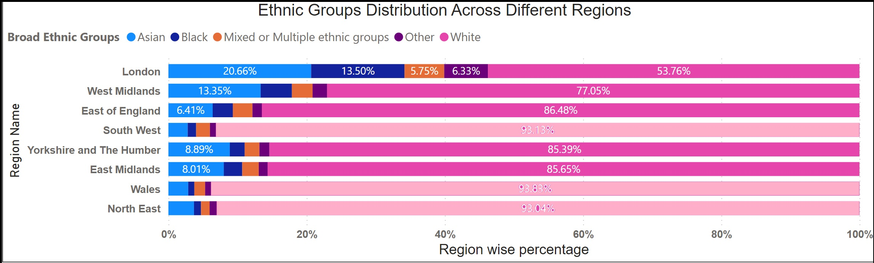

# Diversity of Ethnic groups across constituencies

To see the ethnic diversity across constituencies following steps have been taken: -

Constituency Population Column:

Formula used: - ConstituencyPopulation = CALCULATE (SUM (Ethnicity [Constituency Total]), ALLEXCEPT (Ethnicity, Ethnicity [ONSConstID]))

White Population per Constituency

Formula used: - ConstituencyWhite = CALCULATE (SUM ([Constituency Total]), Filter (Ethnicity,Earlier([ONSConstID]) = [ONSConstID] && (Ethnicity [Broad Ethnic Groups] = "White")))

## Non-White Population per Constituency

Formula Used: ConstituencyNonWhite % = (Ethnicity [ConstituencyPopulation] - CALCULATE (SUM ([Constituency Total]), Filter (Ethnicity,Earlier([ONSConstID]) = [ONSConstID] && (Ethnicity [Broad Ethnic Groups] = "White"))))/Ethnicity [ConstituencyPopulation]*100

After creating these three new columns we created a new table called Diversity rank

Formula Used: Diversity Rank = SUMMARIZE (Ethnicity, Ethnicity [ONSConstID], Ethnicity [ConstituencyName], Ethnicity [ConstituencyNonWhite %]).

Through the Diversity Rank table as created on Number 8 dashboard in power bi we can see constituencies which are most and least ethnic diverse and their rankings as well.

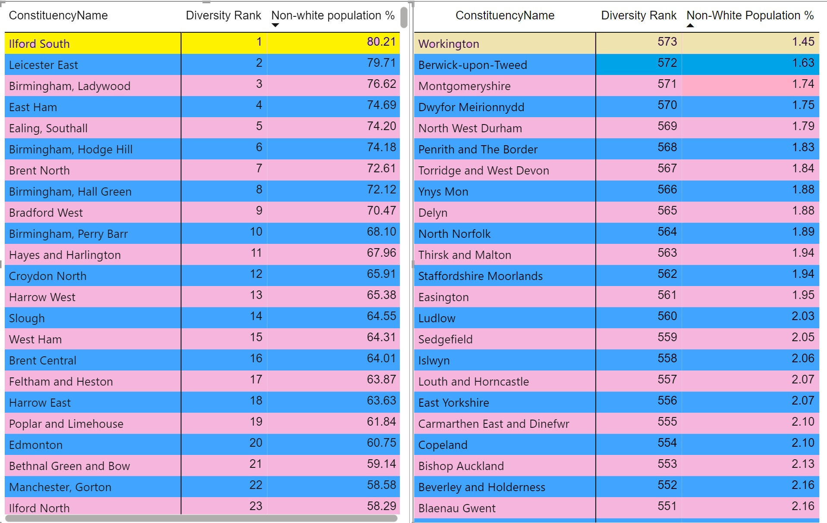

* One of the most ethnic diverse constituencies is Ilford South with (80.21%) as nonwhite population followed by Leicester East (79.71%) nonwhite population.
* The Least Diverse constituency is Workington (1.45%) as nonwhite population followed by Berwick-upon-Tweed (1.63%) nonwhite population.
* With the help of these two tables charts we can parallelly see the most ethnic diverse and least diverse constituencies in England and Wales.

# Socio-economic groups by ethnicity

The socio-economic data source used here is from 2011.

<https://www.ethnicity-facts-figures.service.gov.uk/uk-population-by-ethnicity/demographics/socioeconomic-status/latest/downloads/population-of-england-and-wales-by-ethnicity-and-socio-economic-group.csv>

Data findings on socio-economic groups can be seen From Dashboard 6: -

* out of all socio-economic groups, the largest percentage of white people were found in ‘lower supervisory and technical’ (91.5%), ‘intermediate occupations’ (91.0%) and ‘routine occupations’ (90.9%).
* people from the Asian ethnic group made up 17.5% of the ‘never worked and long-term unemployed’ group and 15.1% of full-time students, around twice their share of the overall population.
* out of all socio-economic groups, the smallest percentages of people from the Asian ethnic group were found in ‘lower supervisory and technical’ (4.7%), and ‘routine and intermediate occupations’ (both at 4.8%).
* black people made up 6.5% of full-time students and 6.2% of the ‘never worked and long-term unemployed’ group.
* out of all socio-economic groups, the smallest percentages of black people were found in ‘small employers and own account workers’ (1.7%), and ‘managerial and professional occupations’ and ‘lower supervisory and technical’ groups (both at 2.1%).

## Percentage of people within each ethnic group in the different socio-economic groups

In the below table the highest percentage data has been filled with gold and second highest with light yellow.

This data shows that:

* 15.4% of people from the Indian ethnic group were in ‘higher managerial and professional occupations’, the highest percentage out of all ethnic groups – altogether, just under one-third (33.1%) of people from the Indian ethnic group were in the 2 ‘managerial and professional’ groups
* out of all ethnic groups, people from the white Irish group were most likely to be in ‘lower managerial and professional occupations’ (at 25.0%), followed by white British (21.3%) and black Caribbean (20.5%)
* 31.2% of people from the white Gypsy/Roma or Traveller ethnic group were ‘long term unemployed or never worked’ – this was the highest percentage out of all ethnic groups, followed by the Bangladeshi (25.3%), Pakistani (24.4%) and Arab (19.7%) ethnic groups
* the white Gypsy/Roma ethnic group also had the highest percentage of ‘small employers and own account workers’ out of all ethnic groups, at 15.1%
* 33% of people from the Chinese ethnic group were full-time students, the highest percentage out of all ethnic groups, followed by the Arab (28.1%) and black African (23.4%) ethnic groups
* Out of all Ethnic groups, enormous number of People from White British were mostly working in Lower Managerial, admin jobs (21.30%), intermediate jobs (13.90%), semi routine occupations (14.80%) and in lower supervisory jobs.

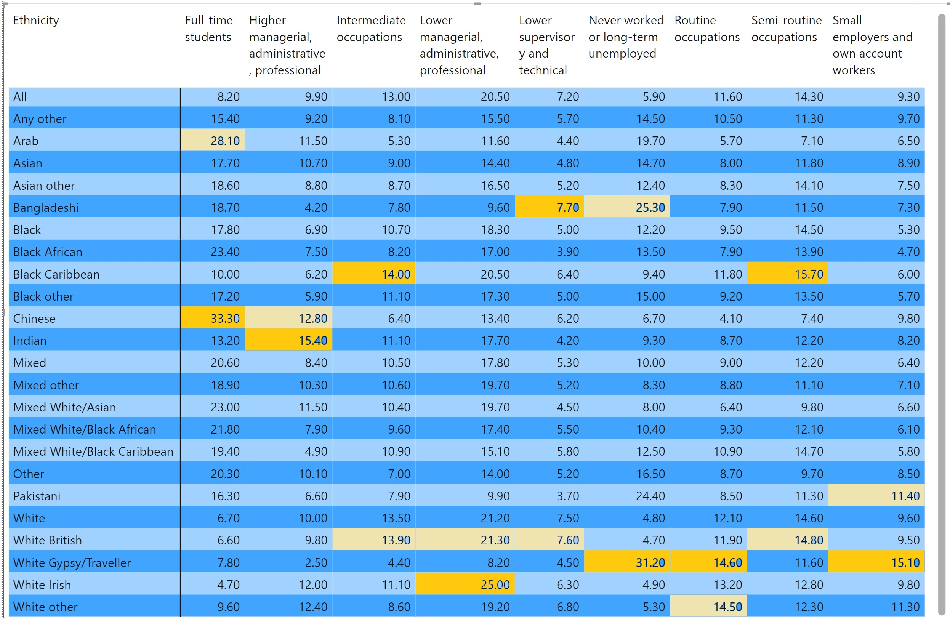

## Percentage of households having multiple ethnic groups varies by Area Name

* Ethnic group composition within the 17.3 million households that had more than one person living in them (69.8% of 24.8 million occupied households). A further 30.2% (7.5 million) of households were occupied by one person.
* Looking in more detail at multiple-person households, in 59.7% (14.8 million) of total households in England and Wales, all household members identified with the same ethnic group. This was a decrease from 61.1% (14.3 million households) in 2011.

The interactive dashboard 5.2 shows how ethnic group composition within households varies at a local level.

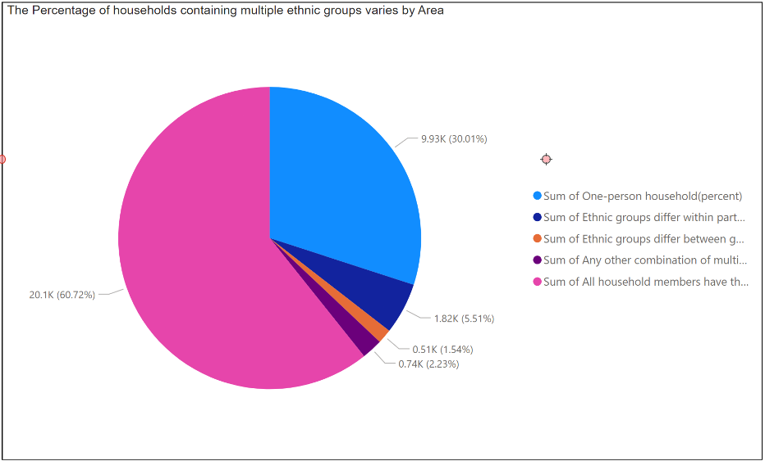

# Geospatial Analysis

Geographic maps to visualize the distribution of ethnic groups across constituencies.

Followed this link to create a distribution of constituencies across England and Wales

<https://www.youtube.com/watch?v=YV6y1pX0-hg>.

The below representation shows the distribution of Indian ethnic group across the England and Wales.

Used color coding to show the density across the constituencies.

Dashboard number 7 for Power Bi but it is a very heavy file, so it takes a lot of time to represent the map.

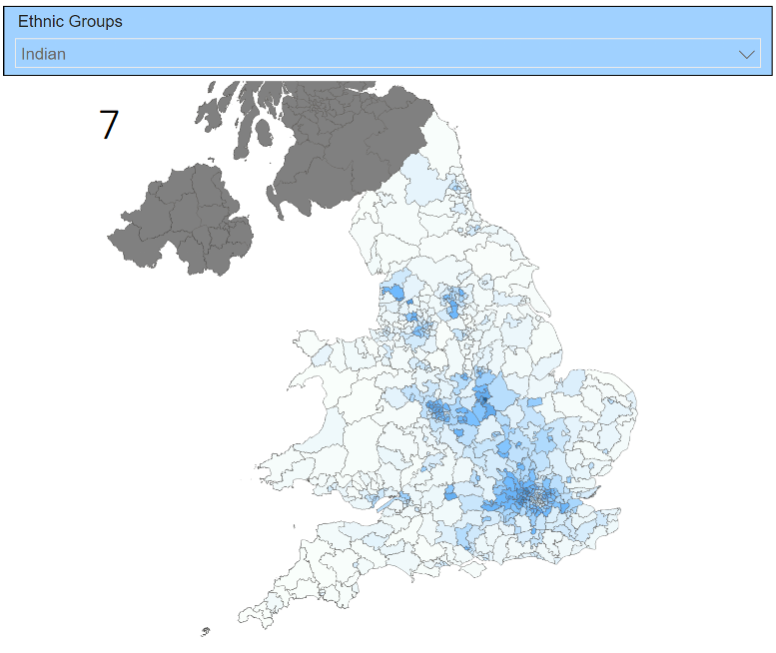

# How can this data inform policymaking and resource allocation?

The ethnicity data set from the House of Commons, based on the 2021 census, offers valuable insights into the ethnic composition of constituencies across the UK. Let us explore how this data can inform policymaking and resource allocation:

By analyzing the data, policymakers can identify constituencies where ethnic minority populations are large.

This information helps target policies and resources to address specific needs, such as language support, cultural integration, and community services.

## Using Dashboards for Actionable Insights

The data dashboards created from this dataset allow policymakers to visualize and understand ethnic diversity briefly.

These dashboards can highlight disparities, trends, and areas requiring attention.

For example, a dashboard might reveal disparities in educational attainment among different ethnic groups within a constituency.

Policymakers can then devise targeted programs to improve educational outcomes.

Similarly, insights on homeownership rates, employment, and health outcomes can guide resource allocation and policy decisions.

For instance, with the help of data dashboard someone can easily see that Leicester East has highest population of Indians in that constituency.

Examples of some policies which might be or may have been implemented in that constituency:

## Language Support and Education

* Establish language centers or community hubs to provide language classes and resources for non-native English speakers.
* Promote bilingual education in schools to ensure students keep their cultural identity while acquiring English proficiency.

## Healthcare Access

* Set up culturally sensitive healthcare services, including interpreters and healthcare professionals who understand the cultural context.
* Address health disparities by focusing on preventive care, mental health services, and awareness campaigns.

## Employment Opportunities

* Encourage businesses to adopt diversity and inclusion practices.
* Facilitate job fairs, vocational training, and mentorship programs specifically for ethnic minorities.

## Community Integration

* Support community events, cultural festivals, and interfaith dialogues to foster understanding and cohesion.
* Invest in community centers where residents can gather, share experiences, and collaborate.
* Housing and Affordable Housing:
* Ensure fair housing practices and prevent discrimination.
* Explore affordable housing initiatives to accommodate diverse income levels.

## Youth Engagement and Recreation

* Create safe spaces for youth, such as sports facilities, art programs, and mentorship opportunities.
* Encourage youth participation in civic activities and leadership roles.

## Anti-Discrimination Policies and Awareness

* Strengthen laws against discrimination based on ethnicity, religion, or race.
* Conduct awareness campaigns to promote tolerance and combat stereotypes. geographic maps to visualize the distribution of ethnic groups across constituencies